1)Write an SQL query to print the first three characters of Country_name from the Country table

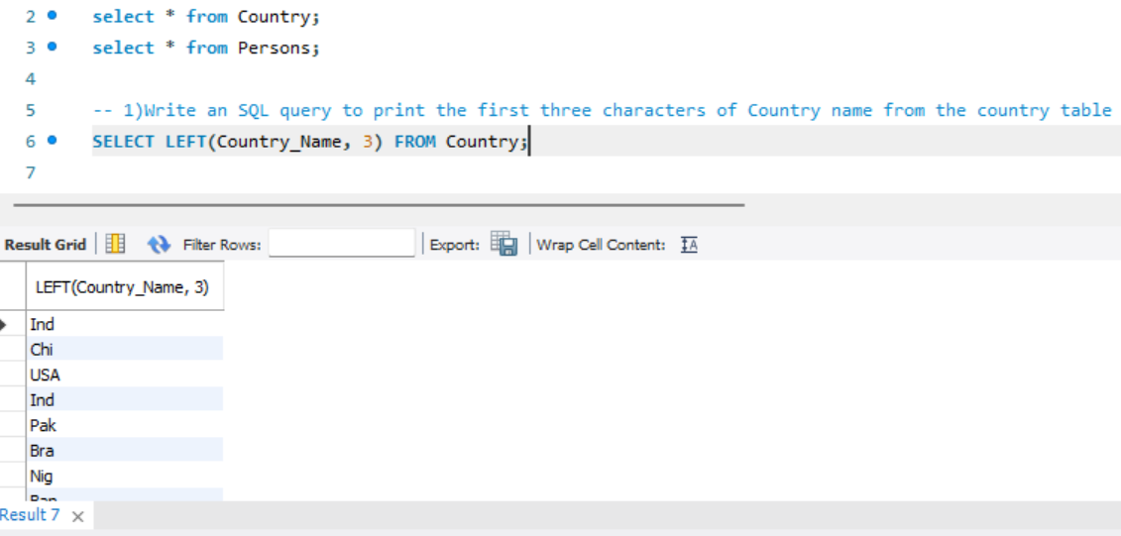

2)Write an SQL query to concatenate first name and last name from Persons table.

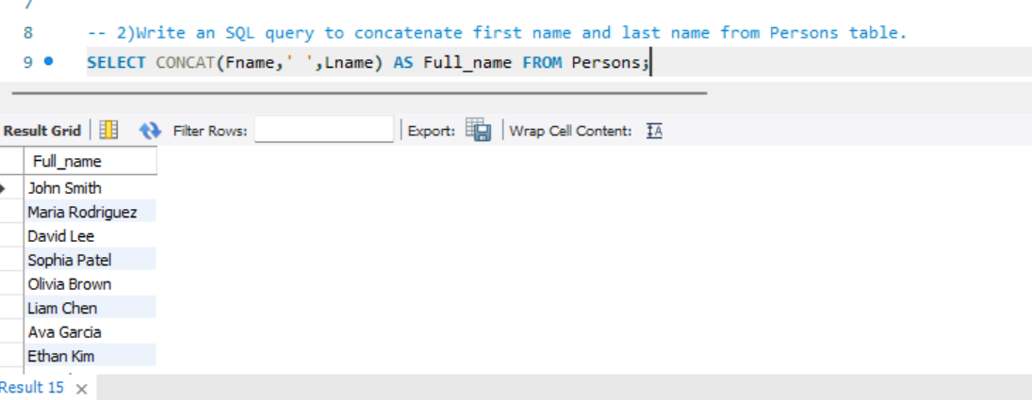

3) Write an SQL query to count the number of unique country names from Persons table

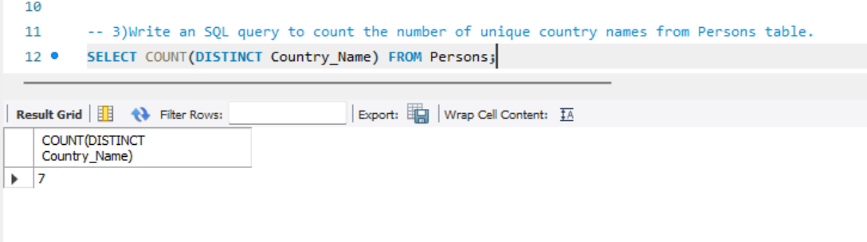

4) Write a query to print the maximum population from the Country table.

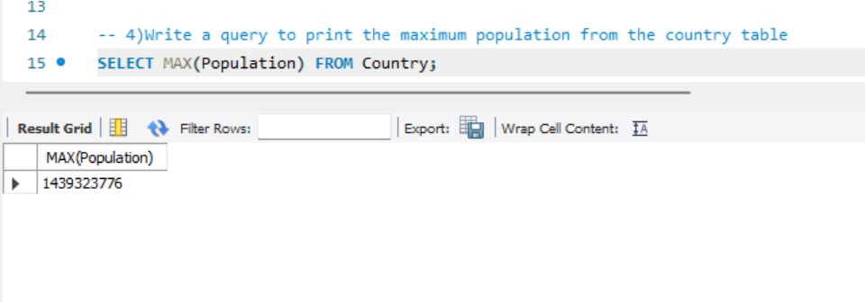

5) Write a query to print the minimum population from Persons table.

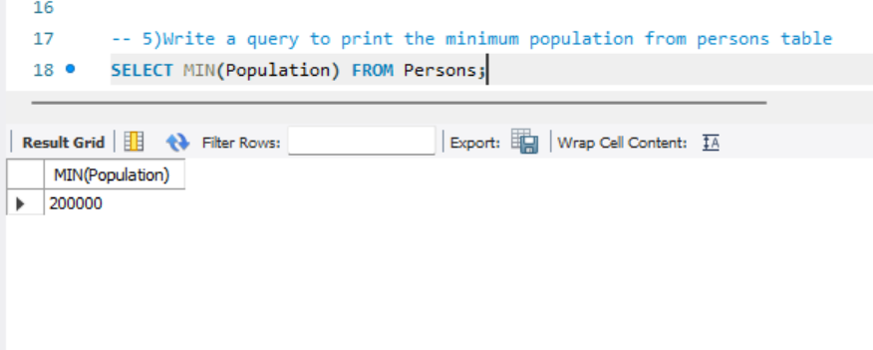

6) Insert 2 new rows to the Persons table making the Lname NULL. Then write another query to count Lname from Persons table

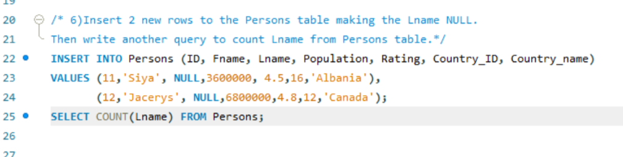

7) Write a query to find the number of rows in the Persons table.

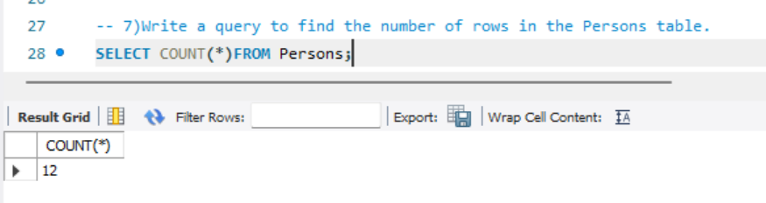

8) Write an SQL query to show the population of the Country table for the first 3 rows.

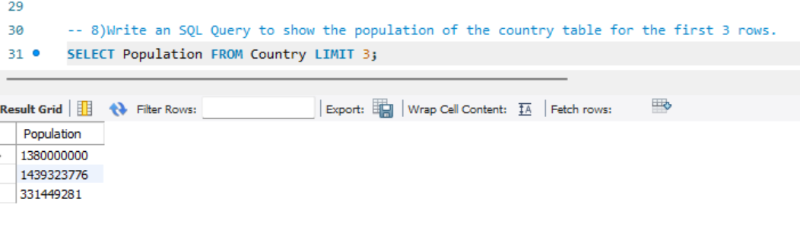

9) Write a query to print 3 random rows of countries.

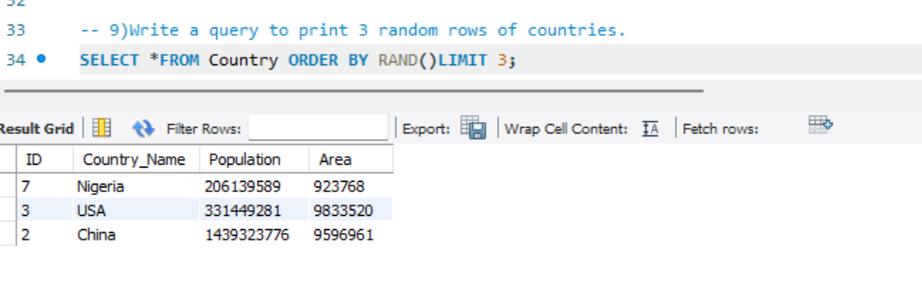

10) List all persons ordered by their rating in descending order.

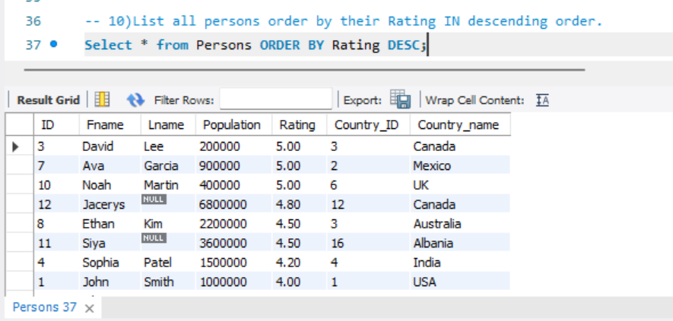

11) Find the total population for each country in the Persons table.

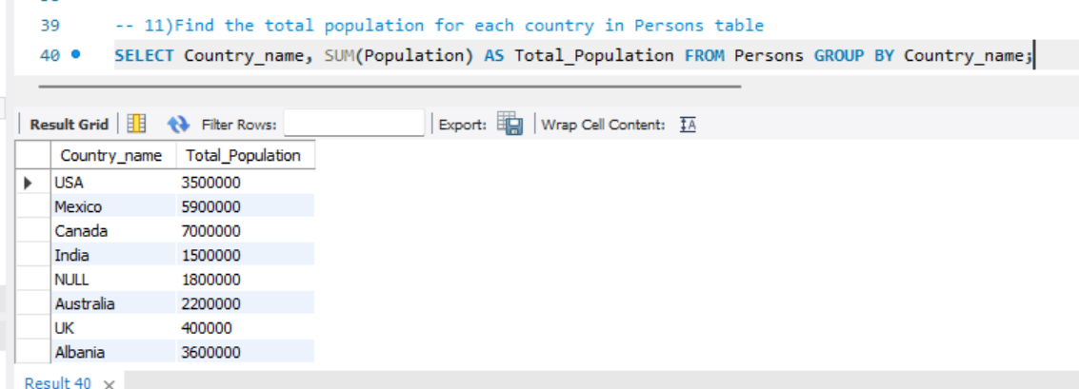

12) Find countries in the Persons table with a total population greater than 50,000



13) List the total number of persons and average rating for each country, but only for countries with more than 2 persons, ordered by the average rating in ascending order.

